**How to run YOLOv7 on NVIDIA DGX**

**Object Segmentation**

* **Log in to Kubeflow** at <http://192.168.12.1:31380> using your credentials on the FIREFOX web browser
* **Start a new notebook server**
  + PyTorch YOLOv7 Image
  + 8 CPU, 16 Ram
  + 1 NVIDIA 20 GB GPU
  + No persistent storage
* **Start a new terminal in Kubeflow, then execute (all subsequent commands need to be executed in the terminal)**
  + cd /workspace/
  + change the directory to this cloned repository
    - cd yolov7/
* **Checkout from the u7 branch by executing the following command**
  + git checkout 44f30af0daccb1a3baecc5d80eae22948516c579
* **Go to seg directory**
  + cd seg/
* **Install requirements with the following commands**
  + pip install --upgrade pip
  + pip install -r requirements.txt
* **Now install YOLOv7-seg weights**
  + wget <https://github.com/WongKinYiu/yolov7/releases/download/v0.1/yolov7-seg.pt>
* **Modification in the code to skip 1st frame:**
* **Go to** yolov7/seg/utils/dataloaders.py/
* **Add:**
* _._ = *self.cap.read()* **on line no. 267**
* **To test the inference capabilities of Yolov7 w.r.t Object Segmentation on a custom image/video**
  + Upload your image/video in the same directory (preferably)

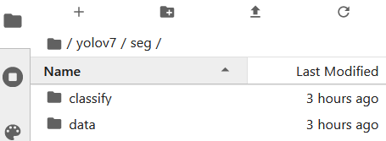

* + python segment/predict.py --weights yolov7-seg.pt --source ‘IMAGE_PATH’ --name coco
* **Explore the results in** */seg/runs/predict-seg/coco*

**How to train YOLOv7 on Custom Data**

**Step 1:** Collect data with a custom class.

**Step 2:** Go to Roboflow and create a new project in your workspace.

**Step 3:** Choose Project Type as *Instance Segmentation.*

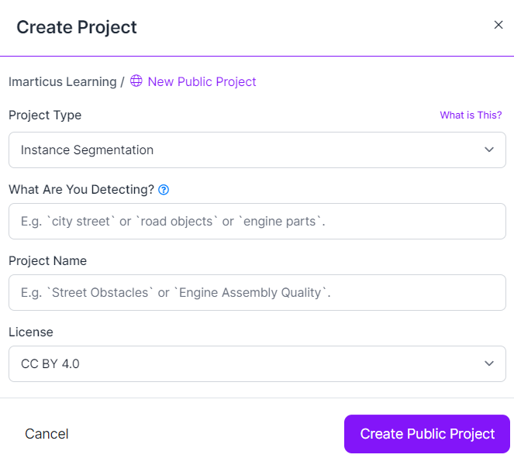

**Step 4:** Annotate your data using *Smart Polygon*

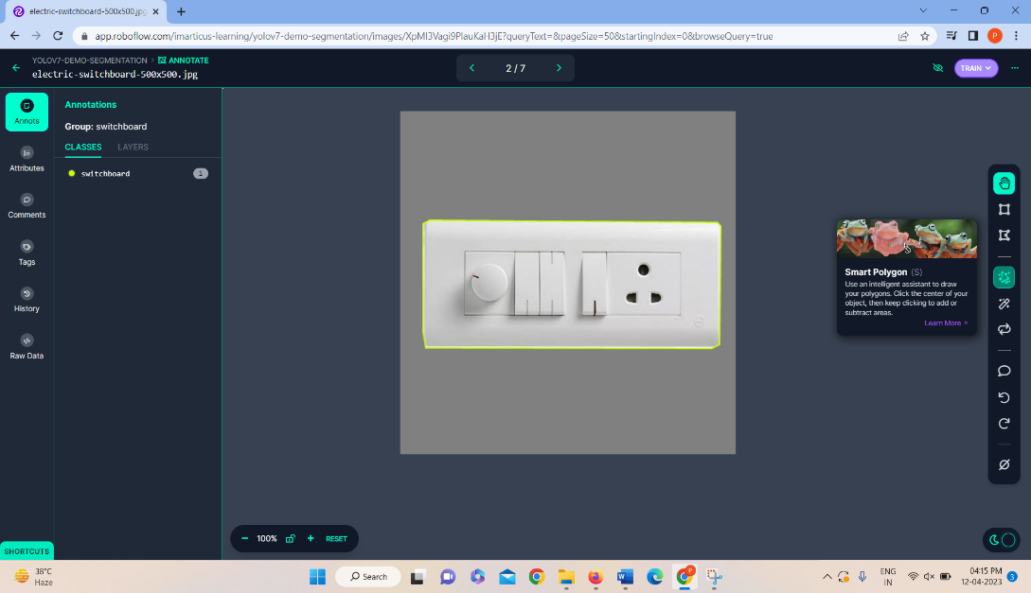

**Note** *- All the codes below need to be executed in the Terminal in yolov7/seg*

* **Export annotated dataset from Roboflow** 
  + Go to Roboflow -> *Version*
  + Then select the dataset and select *Export*
  + The format is *YOLOv7 PyTorch*
  + Select *show download code* -> *Continue*
  + Copy the code under the *terminal* tab

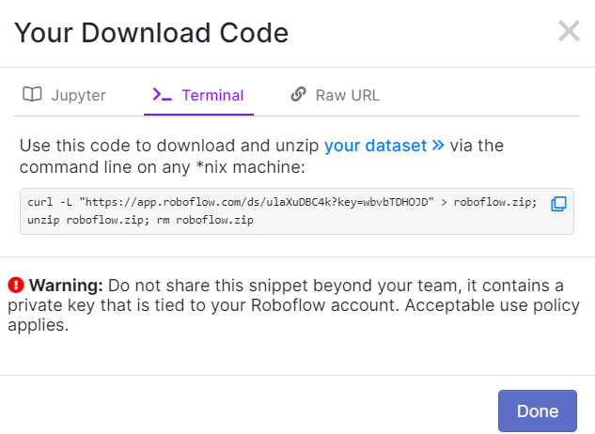

* **Create a new directory inside:** *yolov7/seg/ : mkdir custom_dataset*
* **Go to** *custom_dataset* **and paste the above curl command**
* *cd* custom_dataset/

**Note**: You can use the below code for downloading the annotated sample dataset from my account into DGX:

curl -L "https://app.roboflow.com/ds/ulaXuDBC4k?key=wbvbTDHOJD" > roboflow.zip; unzip roboflow.zip; rm roboflow.zip

* **Update Custom Dataset configuration**
  + Open *data.yaml* file by browsing to *yolov7/seg/custom_dataset/* directory in Kubeflow File Browser
  + Update train, val, and test fields as given below:

*train: /workspace/yolov7/seg/custom_dataset/train/images*

*val: /workspace/yolov7/seg/custom_dataset/valid/images*

*test: /workspace/yolov7/seg/custom_dataset/test/images*

**Note**: Do not make any other changes to the file.

* Copy the updated *data.yaml* to *yolov7/seg/data*
* **Start the training process by running the following command in the directory** *yolov7/seg/*
* **Run:**
* *python segment/train.py --batch 16 --epochs 10 --data data/data.yaml --weights yolov7-seg.pt --device 0 --name test*
* **Explore training results in** *yolov7/seg/runs/train-seg/test*

**TASKS**

* **Do inference on custom class image/video using the trained weights(best.pt) in:** *yolov7/seg/train-seg/runs/test/weights/* directory

**VERY IMPORTANT:** You always need to delete your Kubeflow notebook as soon as you finish your task since it blocks GPU to be utilized by other students!!!

If you fail to do so then your account will be deactivated

